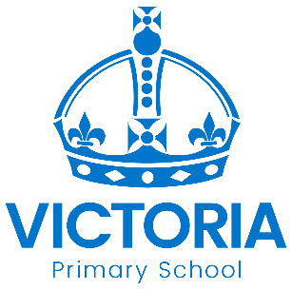

Year 5 Bowden and Fothergill Classes
Newsletter: 2nd September 2020

Dear Parents/Carers,
Welcome back, we hope you enjoyed a fantastic summer break and are ready for an exciting start to Year 5! Mrs Grigorjevs will be teaching Bowden class, she spent part of her summer moving to a new house and chilling out after unpacking and painting!. Mrs Webb will be teaching Fothergill, she spent the holidays wild swimming, camping and enjoying the sunshine (on the odd occasion it came out). Mrs Shafi and Mrs Kearney will be our teaching assistants and they are very excited to work with you all. We have many new things planned and we are looking forward to developing your child’s skills, knowledge and understanding in Year 5.

NASA Training for our Year 5 Space Detectives 2020 : STEM (Science, Technology, Engineering and Maths)
Autumn Term will have a Science focus on the theme of Space. We will start the term with a NASA training camp, learning about the Earth, Sun and Moon then applying our science skills to investigate different materials and their use in space. This will lead nicely into a visit to the National Space Centre and preparing our very own EXPO - more details on this to follow. Our English work will initially focus on report writing and our main text will be Cosmic by Frank Cottrell Boyce. Music will focus on a piece called The Planets by Holst

PSHE (Personal, Social, Health and Economic Education
As we return this year another key focus area for us will be PSHE, this will help us to support children with the transition back into school, help them understand their emotions and re-introduce them to social and behavioural expectations at school. If you have any concerns or questions about your child returning to school please speak to one of us, we are here to help and support.

Uniform and PE Kit
Please ensure your child comes to school in the Victoria School uniform. This includes completely black shoes. They should bring their correct PE kit to school on a Monday and leave it here until Friday as sometimes the timetable can change and this may affect PE days. Everything should be clearly labelled including coats and lunchboxes.

Homework and Reading
There will be an expectation in Year 5 that all children have their reading diary and reading book in school every day. They will be given a suitable text from school but they should also be selecting their own books to read from home or in the classroom.
Children will be given their own homework booklet with English and maths tasks to be completed on a weekly basis. This will also include topic task for the children to work on through out the term.

Trips
Autumn Term 2020 – National Space Centre visit. More details to follow. If you are able to support us on any trips please do let one of us know.

