Year 4 Bronte & Pankhurst Classes
Newsletter: 7th January, 2019

Hello and Happy New Year!

Your Year 4 team
Mrs. Robinson (Monday-Wednesday) and Mrs. Brook (Thursday-Friday) teach in Bronte.
Miss Nock will be returning from Maternity leave later on in the year.
Mr. Pickering is the teacher in Pankhurst.
Miss Hedges (TA) works with children in both classes.

English
This half term we will be reading the story of Rama and Sita to help us write narrative fiction. We will also be visiting a Hindu Temple and be writing recounts about our visit. Please try to read with your children at least 3 times a week at home, as this strongly supports their learning at school.

Maths
In maths this half term, we will be working on fractions and decimals before developing geometry skills by looking at position and direction.

It is very important for the children to continue to learn their times tables up to 12 x 12, as this will help them to multiply and divide when we look at area and when we revisit multiplication and division before half term. Please practise these regularly with your children at home.

Languages
This half term we will be learning Polish. We will first look at the similarities and differences between Polish and British culture and then begin to learn first words and numbers up to 12.

Computing
In computing this half term, we will be focusing on how we can stay safe when online.

Physical Education
Both classes will continue with swimming this half term (Pankhurst will swim on Wednesdays and Bronte will swim on Fridays). Please ensure your child has their kit with them. Should your child require them, please remember hairbands, goggles and a swimming cap.
PE – Thursdays
Please make sure your child brings their PE kit to school. Plimsoll shoes / trainers, shorts and t-shirts are fine but children will need to bring a sweatshirt to school as the weather this half term can be rather cold!

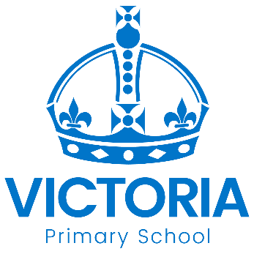

Diary Dates: Spring 2019

Date | Year Group | Time | Event
Tuesday 22nd January | Y3, 4, 5 & 6 | PM | Road Safety Quiz
Tuesday 5th February | All | Day | National Safer Internet Day learning
Thursday 14th February | Y1, 4 &6 | 1.30pm | Language Event: Polish Afternoon
Thursday 14th February | All | 3.15pm | School Closes for February Half Term
Monday 25th February | All | 8.45am | School reopens

