MATHS
Times table activities  Children should make sure they have completed the Autumn term workouts before working through the Spring term section of their booklet. | 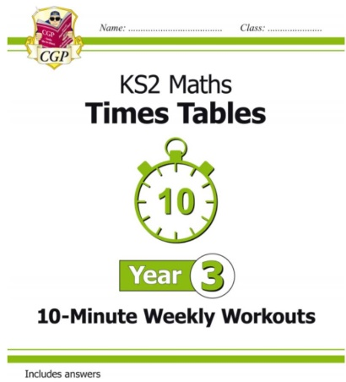  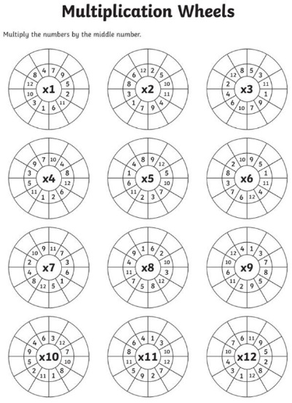
10 Arithmetic activities from Spring term | 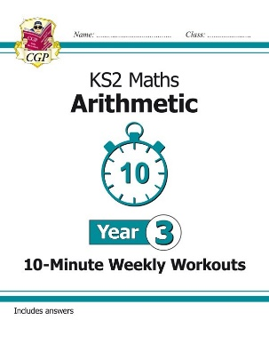
Addition and Subtraction home learning booklet | 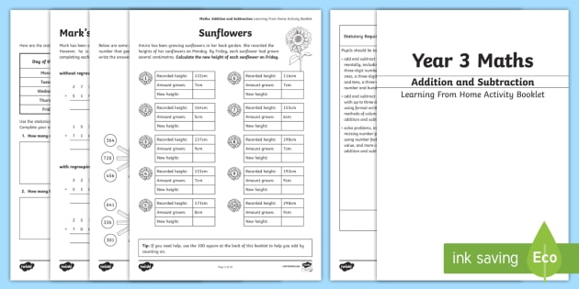
Useful links:
X table games: https://www.topmarks.co.uk/maths-games/7-11-years/times-tables
Dear parents and carers,

This is an outline of what has already been sent home. I realise that it might be difficult to keep track of who’s doing what and who’s got what in a busy house so hopefully this will be a helpful reminder of what your child should be doing over the next two weeks.

I know that you will approach this in a way that works for you and your child. However, I would suggest doing a times table task, another maths task, a spelling task and another English task.

If you have any urgent questions or requests, please get in touch with the office via email and they will pass it on to me. All the best, Miss White and Miss Grieve

ENGLISH
Punctuation task | 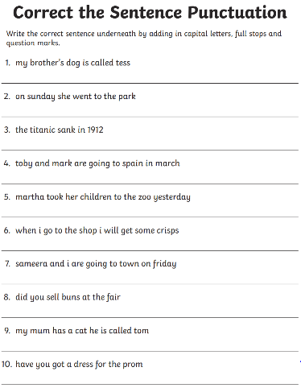
Sentence writing using rainbow grammar (information has been sent home) | 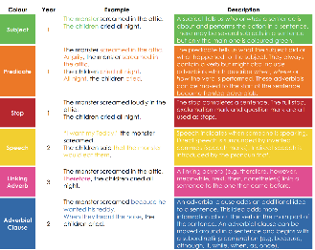
Improving sentences task | 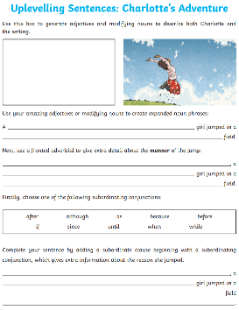
Spelling booklet  Children should work through the activities at their pace. The spellings are at the back of the booklet. | 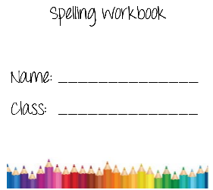

TOPIC
Use this website to find out more about Ancient Egypt! Write down 6 facts you didn’t know before in your pink exercise book. | https://www.dkfindout.com/us/search/ancient-egypt/

