Year 3 Brunel and Stevenson Classes
Newsletter: 28th October 2019
Dear Parents/Carers,

We hope that you and your children have had a lovely half term break. Mrs Russell, Mrs Kaur and I want to begin by saying how proud we are of Year 3’s effort, perseverance and hard work over the last seven weeks. We hope to see this continue as the children build on this fantastic start!

This term, our main topic is LIGHT! We will be exploring this in science as well as in Art and Religious Education. Some of our English learning will be based around light poetry. We will also be doing some work around the story ‘The Firework Maker’s Daughter.’
Maths topics:

Multiplication and Division (3x, 4x and 8x tables)

Reading and writing the time on an analogue clock.

Recognising 3D shapes

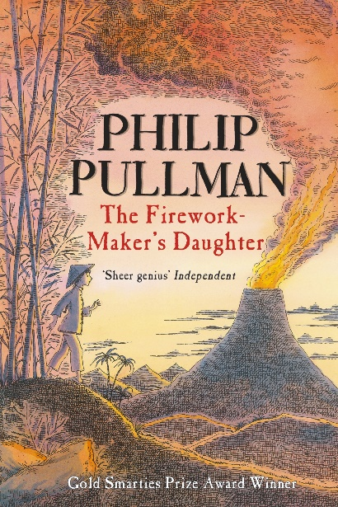
Other areas of learning:

PSHE work will be focused around collaboration.

PE will involve gymnastics and dodgeball.

In Computing, children will create their own simple stop motion animation.
Uniform, lunchboxes and PE kit Please make sure all belongings are clearly labelled. PE kit should be brought into school every Monday and left until Friday.

Homework All children should read for 5-10 minutes every day and record it in their reading diary. Every week, children should learn their spellings as well as complete a basic Maths and English task. Per half term, children will complete a creative topic task.

Please don’t hesitate to ask any questions – we are very happy to help. We appreciate all the support you have provided so far. Many thanks to the parents who volunteered to accompany the children on the local area walk last term.

The Year 3 Team.

Diary Dates: Autumn 2019

Date | Year Group | Time | Event
Wednesday 30th October | Year 4 | All Day | Ancient Greek Day (children are invited to dress up –optional)
Thursday 31st October | Year 6 | 3.00pm | Deadline for applying for a Year 7 place for September 2020
Tuesday 5th November | All | After School | Book Fair in the Sports Hall this week
Friday 8th November | Reception Boot | 08.45 to 10.00 am | Stay & Play session - Boot Class families
Monday 11th November | All |  | National Anti-bullying Week
Wednesday 13th November | Year 5 | Day | Science trip to National Space Centre
Friday 15th November | All | Day | Children in Need Charity Event  Non-uniform day
Friday 15th November | Reception Bell | 08.45 to 10.00 am | Stay & Play session - Bell Class families
Monday 18th November | All | Day | Pupil Individual Photos
Wednesday 20th November | Nursery & Reception | Day | A visitor with owls!
Thursday 21st November | Cadbury | 2.00pm | Open Afternoon for families of  Cadbury Class
Wednesday 27th November | All | 2.00 – 4.30 pm | Parent – Teacher Meetings
Thursday 28th November | All | 3.30 – 6.00 pm | Parent – Teacher Meetings
Wednesday 4th December | All | Day | School Closed for Staff Training
Thursday 5th December | Choir | 3.00 – 4.30 pm | Meadows Christmas Lights Switch On
Friday 6th December | All | lunchtime | School Christmas Meal
Tuesday 10th December | Nursery & Reception | 9.30am | Early Years Christmas Nativity Show
Thursday 12th December | Year 5 | 2.00pm | Space Expo for Year 5 Parents
Thursday 12th December | All | Day | NHS Flu Immunisations (nose spray)
Friday 13th December | All | pm | Christingle at St George’s Church
Tuesday 17th December | Years 1 & 2 | 9.30am  2.00pm | Christmas Show Performance
Tuesday 17th December | Year 1 | Day | Homework Projects Day
Wednesday 18th December | Years 3 - 6 | 9.15am | Family Christmas Sing-along
Wednesday 18th December | All | 3.15pm | School closes for Christmas Holidays

