Learning Project Week 2- My Family
Age Range: ​Year 2
Weekly Maths Tasks (Aim to do 1 per day) | Weekly Reading Tasks (Aim to do 1 per day)
- Tally chart – Look at the people in your house, create different tally charts for the following.  Favourite colour  Favourite food  Get your family to choose their top 5 of each. Record your results in a table.  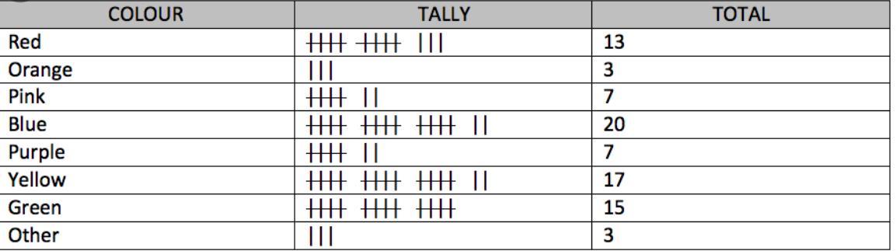  - Learn and practise your 3x table. Can you write it out like 1 x 3 = 3  2 x 3 =  - Place an item somewhere in the room. Use positional and directional language to guide a member of your family to the object.  For example: Walk three steps forward. Turn to the right. Walk forward. Look under the table.  - 3D shape. Go round your house and try to identify where you can see the 3D shapes.  For example a sphere = football  Cube = cardboard box  Challenge: Discuss the properties with your grownup and remember to use vertices, faces and edges.  - Get your grownup to give you a number between 1 – 100.  Write the number that comes before and after this number.  What is the nearest 10 to this number? For example 56 will be 60.  What would you get if you add 10 to this number? | - Try to keep reading at least 5 minutes per day.  - Your child could share a book everyday. This can be reading a book aloud everyday or sharing a book with an adult.  - Listen to the story –  https://www.storylineonline.net/books/the-elves-and-the-shoemaker/  Discuss the story with your grown up and tell them who your favourite character was and what you thought about the ending?  - Watch the Newsround clip and read the text about Ramadam.  Discuss with your grown up  What is Ramadam?  Who takes part in Ramadam?  How long does Ramadam last?  https://www.bbc.co.uk/newsround/23286976  - Create a comic strip based around a book that you have read. Can you remember the characters? Remember to put the events in order.  - Complete a book review on one of the books you have read.  What did you like about it?  What was your favourite part and why?  Who was your favourite character and why?  What was the ‘problem’ in the story and how was it fixed?  Would you recommend it to anyone?
Weekly Phonics/Spellings Tasks (Aim to do 1 per day) | Weekly Writing Tasks (Aim to do 1 per day)
- Your ten common exception words to practice for the week are:  Door, floor, poor, because, find, kind, mind, behind, child, children  Practice these every day and get your grown up to test you on Friday. How many did you get right?  - Use Mr T’s phonics Youtube channel if you require any support with remembering the sounds. https://www.youtube.com/user/breakthruchris  - Watch the video about silent letters. Practise spelling some of these words. https://www.bbc.co.uk/bitesize/topics/zcgv39q/articles/zy4fdxs  - Practise the following digraphs and think of some words that include them.  ar air ear ea ou  Use the words you have made in sentences.  - Write these words onto paper. Sort them into a pile of words that are spelt correctly and words that are spelt incorrectly.  Wen fink that  Woz aftur thier  They because skool  Every pritty were | - Write some rainbow grammar sentences about what your family do around the house. Remember to include:  A subject – Who  A predicate – what they’re doing  Stop – punctuation  Example 1: My mum is cooking in the kitchen.  Challenge: add a fronted a fronted adverbial  Example 2: Carefully, dad fixed the car that was sitting on the drive.  - Interview a family member. Think of ten questions that you could ask a family member to get to know them better.  What is your favourite food?  How long have you lived in this house?  Try to think about creative questions with a range of question starters.  - Create a quiz about your family. Write some questions about your family and then play this with your grown up. How did they do?  If you have a small family include questions about uncle and aunts in your quiz.  - This activity should be done over two days as it is a larger task. Create a story using your family as the characters.  Create a plan if you need to.  Remember to add story language and interesting vocabulary.  Be a creative cat and make your story interesting.

______________________________________________________________________________

Design a personal coat of arms shield for the family:

Find out what a coat of arm shield means. Use the link below to support you.
https://kids.kiddle.co/Coat_of_arms

What could they draw?
What does it mean to them ?
Think about the colours and shapes.
Maybe if they have some cardboard around the house they could make a shield to give to a family member.
Below shows some things that might have been included on a coat of arms that you can include on yours too.

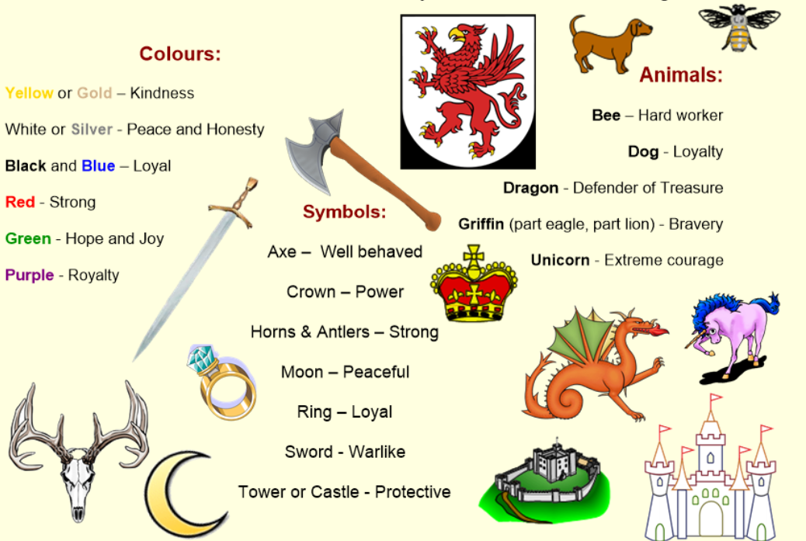

Here are some ideas below.

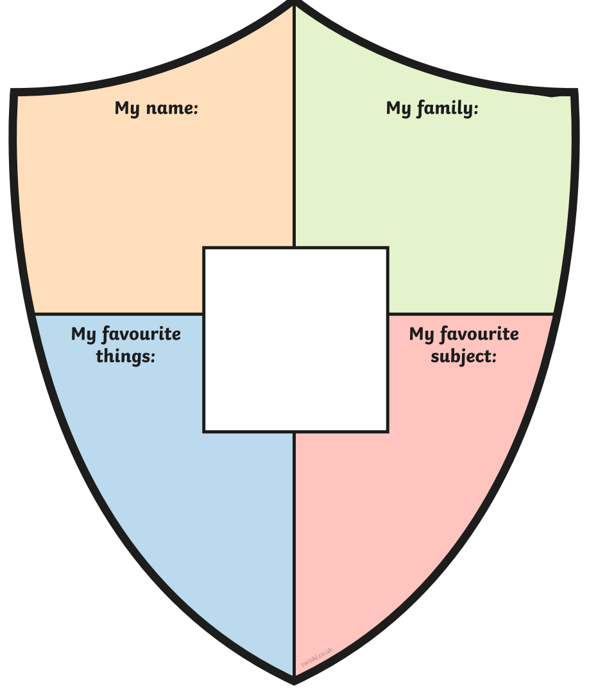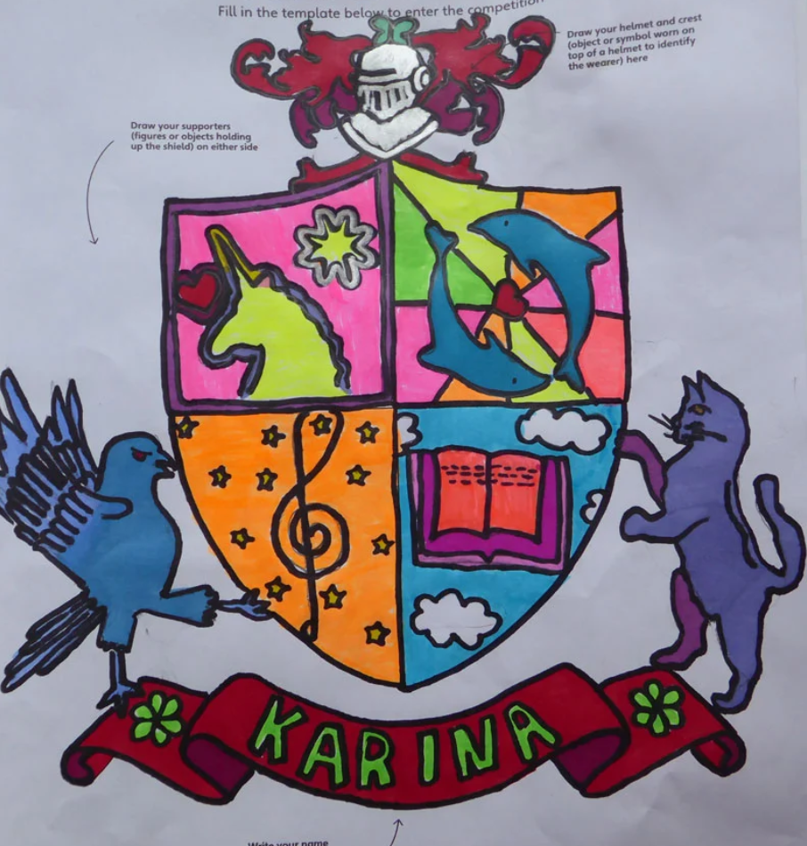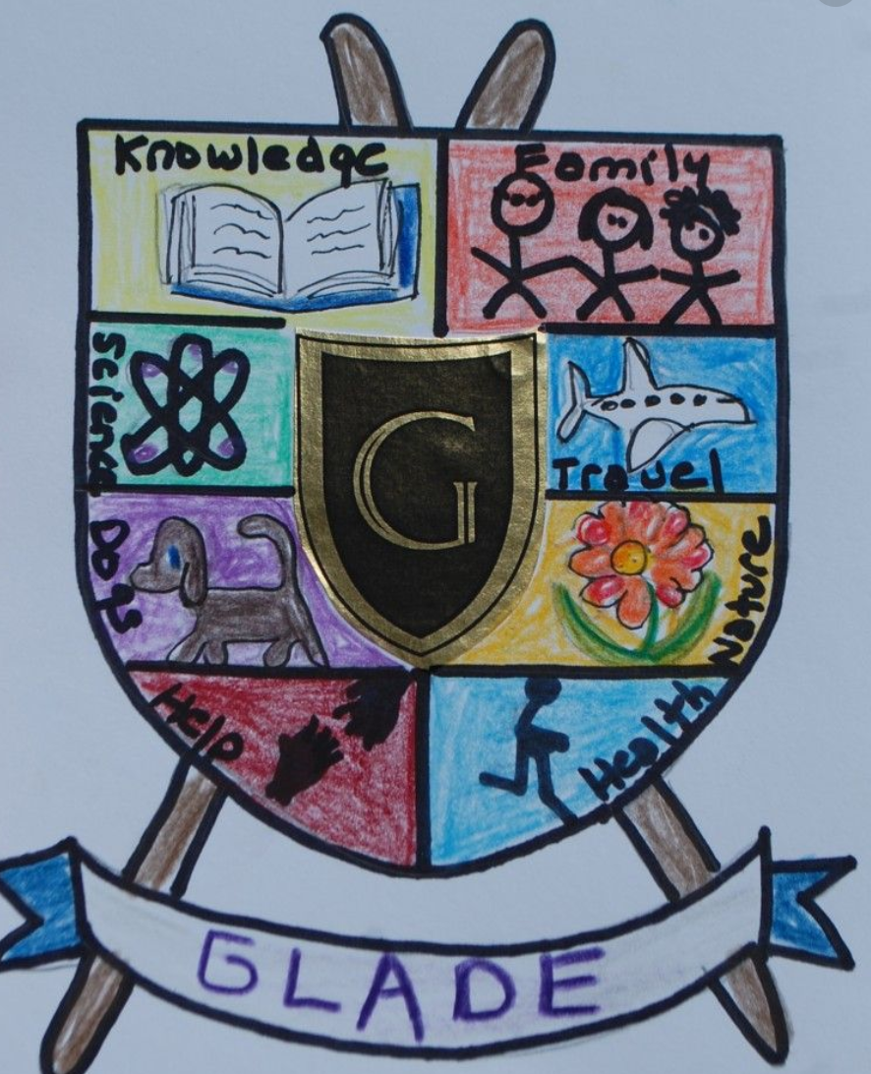

Write an invitation to a family event:
Create and invitation to invite a family member to one of the following: ​ -​
talent show, music show, magic tricks, jokes show
Think about the time, date and place.
How will you design the invitation? How will you make it eye-catching?

Create a piece of family hand art:
Using paint, paper, pencils or anything you have around the house, have a go at a piece of art work together with your family.
Below are some examples of things you could do.
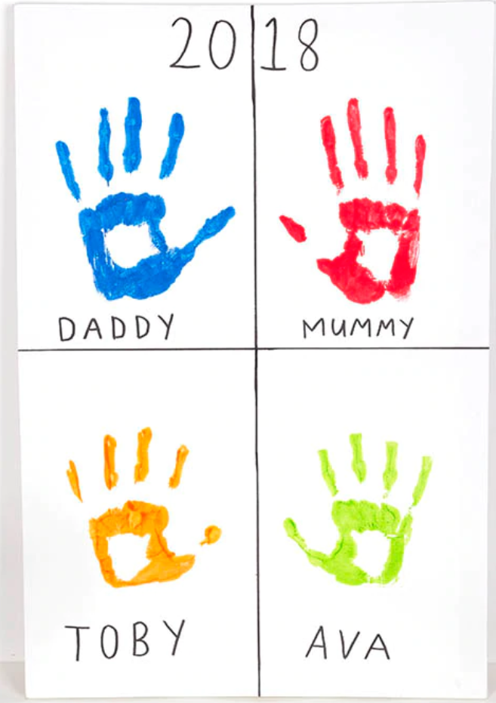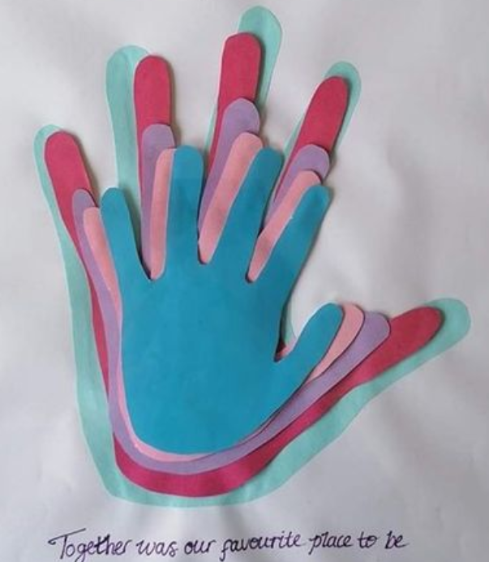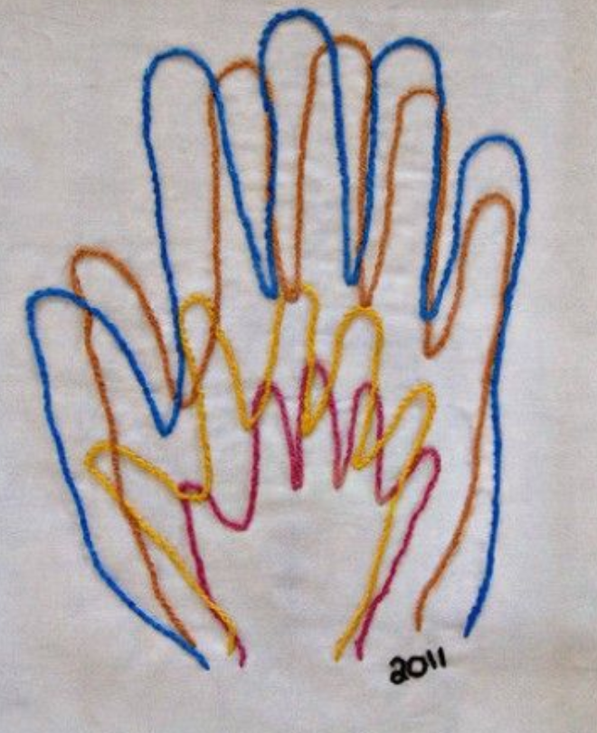
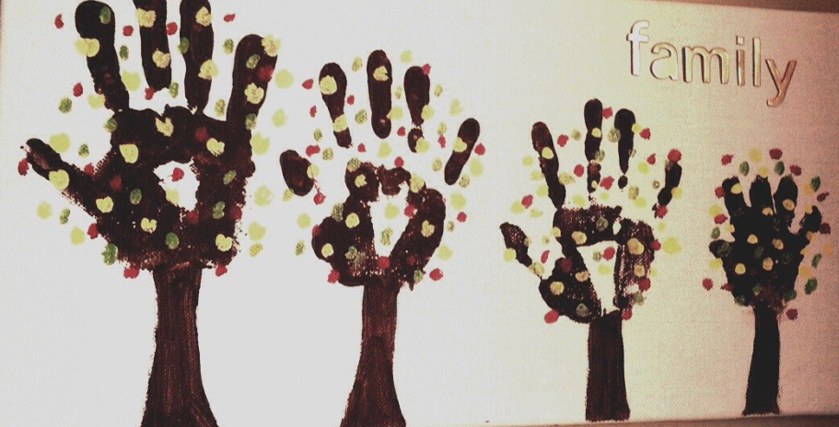

Additional learning resources parents may wish to engage with
Classroom Secrets Learning Packs -​ These packs are split into different year groups​ and include activities linked to reading, writing, maths and practical ideas you can do around the home.
Twinkl ​ - to access these resources click on the link and sign up using your own email​ address and creating your own password. Use the offer code UKTWINKLHELPS.
Headteacherchat - This is a blog that has links to various learning platforms. Lots of​ these are free to access.

Additional Year 1 phonics support can be found here: https://home.oxfordowl.co.uk/reading/learn-to-read-phonics/

Additional year 2 work to support SATs can be found here:
https://www.theschoolrun.com/key-stage-1-sats-learning-journey

#TheLearningProjects

