Learning Project WEEK 4 – Areas around you and the world.
Age Range: ​KS1
Weekly Maths Tasks (Aim to do 1 per day) | Weekly Reading Tasks (Aim to do 1 per day)
- Create a pack of number sentences using your 3 and 5 times tables.  E.g. 1 X 3 = / 3 X 5 =  Get your grown up to test you on your times tables by flashing up the cards and you must answer the number sentences.  How quick were you? Practise the ones you got incorrect. We would love to see a video of this!  - Can you draw a map of an imaginary town and give your grown up directions to follow. to get to certain parts of the town. E.g. Go left and follow the road. Turn a quarter clockwise to look at what?  - Solve these maths problems:  - Beth has 95p. Rob has 43p. How much more does Beth have than Rob?  - Debbie measures a plant. Last week it was 25cm, this week it is 63cm. How much has it grown in a week?  - Travis says that he has 330kg of water in his cup. Has Travis used the correct measurement? Prove your answer.  - Write the numbers 60-80 in words and  digits. Remember the correct spelling of 8.  - Compare the weight of two objects using the greater > and less than < symbols. If you have scales at home, compare the weights and write these down. | - Reading a variety of books at home. Your child could share a book everyday. This can be reading a book aloud everyday or sharing a book with an adult. Please feel free to upload a short video of your child reading as we miss hearing them.  - Watch and read the Newsround clip of Vesak festival. https://www.bbc.co.uk/newsround/48106687  Who celebrates this festival?  Who is Siddhartha?  What activities do Buddhists do during  the festival?  - Watch the story ‘Hey That’s My Monster!’  https://www.storylineonline.net/books/hey-thats-monster/  Discuss the story with your grown up.  Can you tell your grown up what the problem in the story was and how was it overcome?  Can you review the story (via video or paper) and write a short summary of what it is about?  - Role play the story with your family, Try to include words from the story. Remember to use expression when performing as a character. We’d love to see some of these!  - Turn ‘Hey That’s My Monster’ into a comic strip. Be creative with this and use lots of interesting vocabulary, pictures and colour!
Weekly Phonics/Spellings Tasks (Aim to do 1 per day) | Weekly Writing Tasks (Aim to do 1 per day)
- Your ten common exceptions words to practise for the week are:  every, everybody, eye, fast, father, find, floor, gold, grass, great  If you find these easy, try some year 3 common exceptions:  accidently, century, experiment, interest, particular, remember.  Practise these everyday and get your grown up to test you on Friday.  How many did you get right?  - Practise the following split vowel digraphs and think of some words that include them:  a_e , i_e , o_e, u_e, e_e  Use the words that you have made in sentences.  - Write these words on to paper. Sort them into a pile of words that spelt correctly and incorrectly.  Christmus crayon underneath  popcorn whent cayke  swich elefant befour  coyn vanish finaly  - Can you read these words and research the meanings of them:  discover, experiment, colossal, apprehensive.  - Watch the videos about exclamation marks.  https://www.bbc.co.uk/bitesize/topics/zrqqtfr/articles/zqbjy4j  Can you write some sentences that include these? | - Explore the setting picture (we have uploaded this separately)  What can you see in the picture?  How do the colours make you feel?  What makes the picture stand out for you? You can write these down to help you or just discuss this with your grown up.  - Create a bank of adjectives to help you describe the setting. Be creative with this and for an extra challenge, try to use expanded noun phrases. Remember if you use more than one adjective before the noun, you need a comma.  - Explore the picture. Can you write some similes to describe what you can see and make the reader feel like they are in the picture?  E.g. The water was black as the night. The water is cold like ice.  - Use the picture to write a setting description of what you can see. You must use interesting adjectives, expanded noun phrases and similes.  This piece should be based over two days so please take your time with it. If you finish on day one, please edit you work to improve it on day 2.  Remember to use the correct punctuation (capital letters, spaces, stops) and concentrate on making your handwriting as neat as possible, especially if you have learnt to join your letters.

Learning Project - to be done throughout the week: Where do you live?
The project this week aims to provide opportunities for your child to learn more about the area in which they live. Learning may focus on your local area, famous people, key landmarks and links to your city.

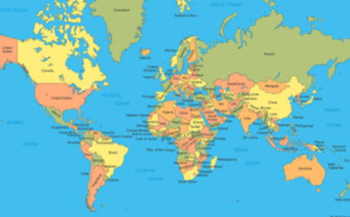
Locating where we live:
Can you find the UK on the map below?
Can you name all of the countries within the UK?
Which country do we live? What is the capital of our country?
Why do you think the countries begin with a capital letter?

Please note, the map will be uploaded separately on SeeSaw or use a globe, atlas or anything else that will help to explore the map of the world.

Mini beast hunting:
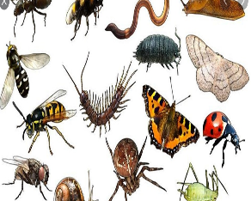
What insects or creepy crawlies can you find within your garden
or on your daily walk?
Can you identify the mini beast? What features does it have?
What is its habitat and how might that help the creature?

Remember, do not touch any of the mini beasts as some insects can be
poisonous or may sting or bite. This activity should be done with your
grown up.

Making the community happy:

Draw a picture of something to cheer people up
and put in your window.
This could be of a rainbow or you could be even more
creative and think of something else that will brighten
up someone’s day.
Additional learning resources parents may wish to engage with
Twinkl ​ - to access these resources click on the link and sign up using your own email​ address and creating your own password. Use the offer code UKTWINKLHELPS.

#TheLearningProjects

