Learning Project WEEK 3 - Area you live in
Age Range: ​KS1
Weekly Maths Tasks (Aim to do 1 per day) | Weekly Reading Tasks (Aim to do 1 per day)
- Continue to practise counting in 2s, 3s,  5s and 10s.  Can you write your calculations out?  E.g. 1 X 3 = 3, 2 X 3 = ?  - Explore:  https://www.bbc.co.uk/games/embed/karatecats2?exitGameUrl=http%3A%2F%2Fbbc.com%2Fbitesize%2Farticles%2Fzf4sscw  Can you beat your best score?  - Create a card game that is based around making number pairs to thirty that can then be played as a family.  E.g. 15 and 15 , 20 + 10 , 21 + 9  - Solve these time problems:  - Beth got on a train at 1’o’clock and the journey lasted 2 and a half hours. What time did she get home?  - Rob went for a run at 12:30. He got home at 1:15. How long did he go running for? Use your 5 times table to help you.  - Debbie put a cake in the oven at 4’o’clock. She took it out at quarter past 5. How long was the cake baking for?  - Write the numbers 40-60 in words and  digits. | - Reading a variety of books at home. Your child could share a book everyday. This can be reading a book aloud everyday or sharing a book with an adult. Please feel free to upload a short video of your child reading as we miss hearing them.  - Watch and read the Newsround clip of the dolphin rescue.  https://www.bbc.co.uk/newsround/  news/watch_newsround  How did the people rescue the  dolphin?  Why did the dolphin struggle to get  back into the ocean?  Where was the dolphin found?  - Watch the story ‘Zombies don’t eat veggies’  https://www.storylineonline.net/books/zombies-dont-eat-veggies/  Discuss the story with your grown up.  Which part was your least favourite favourite?  Who was your favourite character and why?  If you could change the ending, what would it be?  - Create a mask of one of the characters from ‘Zombies don’t eat veggies’.  Can you role play and pretend to be the character? We would love to see videos of this! Try to use dialogue from the story when you are being your character.  - Watch the story ‘Voices In The Park’.  Discuss the illustrations (pictures). How do the pictures help to tell the story?  https://www.youtube.com/watch?v=QYv94oUa_IM
Weekly Phonics/Spellings Tasks (Aim to do 1 per day) | Weekly Writing Tasks (Aim to do 1 per day)
- Your ten common exceptions words to practise for the week are:  Christmas, class, climb, clothes, most, only, both, old, wild and cold.  Practise these everyday and get your grown up to test you on Friday.  How many did you get right?  - Practise the following digraphs and think of some words that include them:  or, oa, ir, ur, er.  Use the words that you have made in sentences.  - Write these words on to paper. Sort them into a pile of words that spelt correctly and incorrectly.  think there were  wud worter drinc  por bewtiful hapee  half happy but  - If you need support with phonics, watch Mr T’s phonics  https://www.youtube.com/user/breakthruchris  - Watch the videos about homophones.  Practise these words within sentences.  https://www.bbc.co.uk/bitesize/topics/zqhpk2p | - Ask your child to imagine that they live in the castle below.  What would they see? Write sentences using interesting adjectives and expanded noun phrases.  - Write your address: Discuss with your child. Do they know who delivers the post? Share a letter with them and explore the envelope from the front and back. Who is the letter addressed to? Ask your child to write their address on the envelope. Discuss the postcode and any capital letters? .  - Write a letter to the Queen and post it.  Think about what questions you would like to ask then Queen and tell her about yourself.  The Queen’s address is:  Her Majesty The Queen  Buckingham Palace  London SW1A 1AA  The letter writing activity should be based over two days, to allow children to edit their work and re-write it.  - Using the ‘Town Map’ (that has been uploaded in the activity section of SeeSaw) can you write instructions to guide someone around the map?  E.g. First, carefully walk across the rickety bridge but try not to fall in the hole.

Learning Project - to be done throughout the week: Where do you live?
The project this week aims to provide opportunities for your child to learn more about the area in which they live. Learning may focus on your local area, famous people, key landmarks and links to your city.

To develop knowledge of the location of significant places:
Ask your child to look at where they live. What can they see outside the
window in the front of their house? At the back of their house?
What could they find near them? Do they know the name of their street?
Can they create a street sign with their street name?

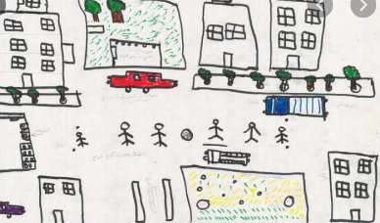
Draw a picture of your street. Support your child to take a look
at the street and buildings around​ where they live.
Encourage them to think about the shape of the buildings.

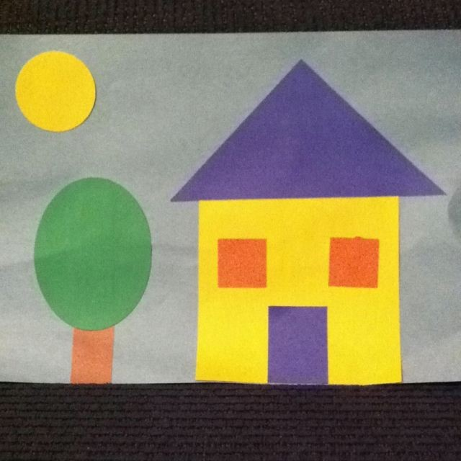
Shape hunt:​ Take your child on a shape hunt around their house and garden.
Look at the different shapes of the windows, doors, and houses. Can they name them? Are they 2D or 3D shapes? Ask them to create a picture of their house or street.

Additional learning resources parents may wish to engage with
Classroom Secrets Learning Packs -​ These packs are split into different year groups and​ include activities linked to reading, writing, maths and practical ideas you can do around the home.
Twinkl ​ - to access these resources click on the link and sign up using your own email​ address and creating your own password. Use the offer code UKTWINKLHELPS.
Headteacherchat - This is a blog that has links to various learning platforms. Lots of these​ are free to access.
#TheLearningProjects

