**Year 2 Wordsworth & Tennyson Classes**

**Newsletter: 5th November 2018**

Dear Parents/Carers

What a fantastic start to Year 2 last term! We are really proud of all of your children and we can’t wait for this term to beginning because we have a lot of exciting things for everyone.

**Topic**

Our topic for this half term is ‘The Great Fire of London’. We will be using a range of skills discover the significance of ‘The Great Fire of London’ and how it affects London today. We will be learning about the role of Samuel Pepys as a source of information about the Great Fire of London. Through design and technology, we will understand how the houses were built and why this tragic event happened.

**Maths**

Our first Maths unit is Multiplication and Division. By the end of Year 2 we need to know our 2, 5 and 10 times table. We will be launching a times table challenge. You can get some maths practice in at home by practising quick recall of the times tables.

**Reading**

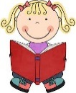Reading at home plays a vital role in developing your child’s learning and can have a massive impact on their progress in school. Your child will bring home a book matched to their reading level and should be encouraged to talk about what is happening in the story and to make predictions as well as reading aloud. Please make sure that you children bring in their reading book and diary everyday as this helps us keep track of and makes sure that we are able to support your child in their reading as well.

**English**

In English this term we will be concentrating on developing the children as writers. We will be taking the skills that we learnt last term and implementing them this term. Spelling plays a key role in year two and therefore the children’s spellings will be sent home. If you could support your child in learning these that would help them with their writing as well.

**Belongings**

Please label jumpers, cardigans and coats. We constantly remind the children to take care of their belongings but ultimately it is their responsibility. We will do our best to find missing property and having their name in things really helps!

Should you have any questions about any aspect of school life, please do not hesitate to speak to any member of our team.

Kind Regards

Miss Mullins Miss Cao & Miss Evans Mrs O’Connor

Wordsworth Class Teacher Tennyson Class Teachers Teaching Assistant

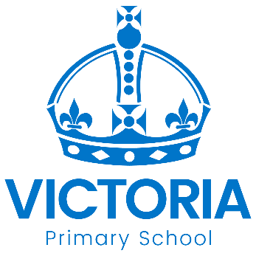

**Diary Dates: Autumn 2 2018**

|  |  |  |  |
| --- | --- | --- | --- |
| **Date** | **Year Group** | **Time** | **Event** |
| Thursday 8th November | Year 6 | pm | WW1 Centenary Football Match Event |
| Friday 9th November | All | Day | WW1 Centenary Activities |
| Monday 12th November | All | Week | National Anti-bullying Week |
| Tuesday 13th November | R – Y5 | Morning | NHS Flu Vaccinations  *Nose Spray not injection* |
| Thursday 15th November | Year 2 | 9.00 – 10.00 am | Phonics for Parents workshop & watch |
| Friday 17th November | All | Day | Children in Need Charity Event |
| Tuesday 20th November | All | 2.00 – 3.30 pm | Parent and Family Support Event |
| Wednesday 21st November | All | 2.00 – 4.30 pm | Parent – Teacher Meetings |
| Thursday 22nd November | All | 3.30 – 6.00 pm | Parent – Teacher Meetings |
| Tuesday 4th December | Year 2 | AM | English Trip to Pantomime  at Nottingham Playhouse |
| Wednesday 5th December | Year 3 - 6 | 2.30 – 4.30 pm | Choir singing at Christmas Lights  Switch – on at Bridgeway Centre |
| Friday 7th December | R – Y6 | pm | Christingle Experience at  St George’s Church |
| Tuesday 11th December | Nursery & Reception | tbc | Christmas Show for families |
| Tuesday 18th December | Year 1 & 2 | tbc | Christmas Show for families |
| Wednesday 19th December | All | 3.15pm | School Closes for Christmas Holiday |