Year 1 Learning Project –Week 10 – The Environment
29th June – 3rd July 2020
 | Monday | Tuesday | Wednesday | Thursday | Friday
Writing/Topic | Write about the picture. | Plant and flower hunt | Label the parts of a plant and explain their functions. | Science experiment – make a prediction. | Science experiment – explain the results.
Phonics/spelling | Read and draw | Weekly phonics challenge | Phase 4 read and match | Spelling, punctuation and grammar activity mat | Common exception word mat – says
Reading | Read to an adult for 10 minutes each day / adult reads to child for 10 minutes each day
Maths | Number of the day | Activity mat | Weight activity | Ordinal numbers | Missing numbers

Name: ____________________________________________
Monday 29th June
Writing Challenge - Use this picture as the inspiration for your next great story, poem or description. Challenge yourself to use some of the exciting vocabulary we've learned to make your writing even more amazing. The words in the box might help you this week.
discover unusual habitat vanished gloomy

_______________________________________________________________

_______________________________________________________________

_______________________________________________________________

_______________________________________________________________

_______________________________________________________________

_______________________________________________________________

_______________________________________________________________
Monday 29th June
Phonics – Read and draw
Read the words and draw the correct thing in each box. Can you highlight the compound words?

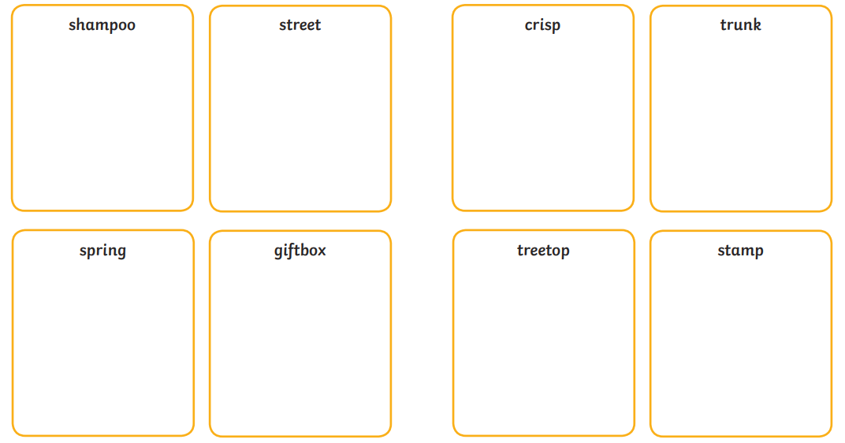

Monday 29th June
Maths – Number of the Day

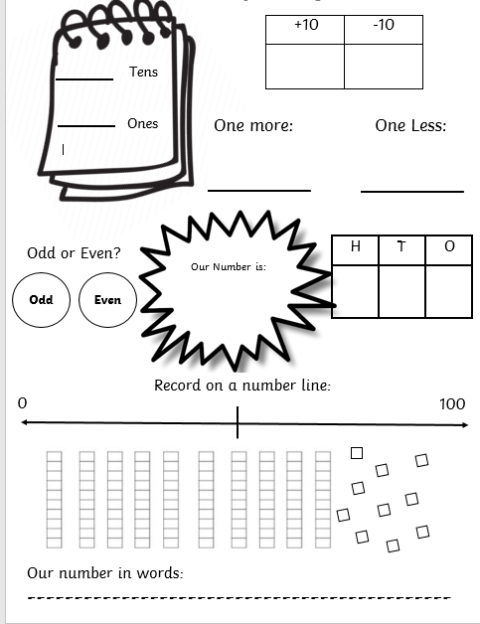
76

Tuesday 30th June
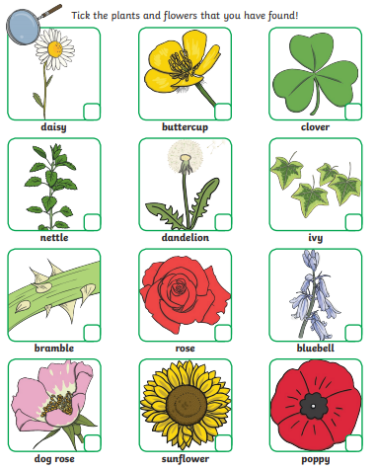
Topic – Plant and flower hunt
Look in your garden or go to a local park with an adult. Tick off the plants and flowers that you find. Can you find them all? What else did you find?

Did you find anything else?

_________________________________________________________________

_________________________________________________________________

_________________________________________________________________

_________________________________________________________________

_________________________________________________________________

Choose the sound for the phonics group you are in. How many words can you come up with that have this sound in them? Can you use your favourite one to write a sentence? Can you find this sound in books and magazines at home?

Tuesday 30th June
Phonics – Weekly Phonics Challenge

4 | oy |  | Words that end in “ing”
 | f |  | oe

_____________________________________________________________________________________________________________________________________________________________________________________________________________________________________________________________________________________________________________________________________________________________________________________________________________________________________________________________________________________________________________________________________
____________________________________________________
Today we want you to use your number skills to answer these questions. Remember if you are stuck, to use objects from around your house – Lego, stones, buttons.

Tuesday 30th June
Maths – Activity Mat

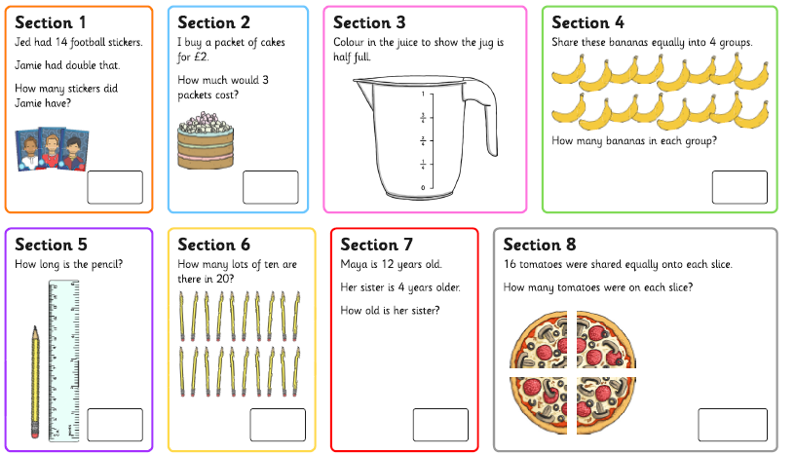

Can you label each part of the plant? Can you write about the function of each part? Remember the word ‘function’ means the job that something does.
Wednesday 1st July
Topic – Parts and functions of a plant
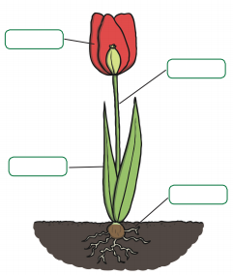

____________________________________________________
____________________________________________________
____________________________________________________
____________________________________________________
____________________________________________________
____________________________________________________
Read the words and match to the correct picture.
Challenge – choose 3 words and use these to write sentences on the next page.

Wednesday 1st July
Phonics – Phase 4 Matching
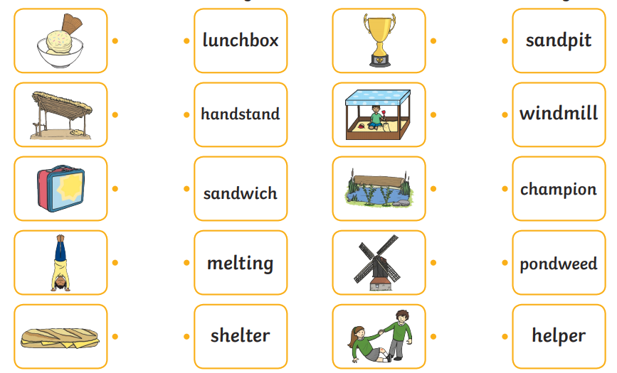

____________________________________________________
____________________________________________________
____________________________________________________
____________________________________________________
____________________________________________________
____________________________________________________
____________________________________________________
____________________________________________________
____________________________________________________
____________________________________________________
____________________________________________________
____________________________________________________
____________________________________________________
____________________________________________________
____________________________________________________
____________________________________________________
____________________________________________________
____________________________________________________

Wednesday 1st July
Maths – Weight

Look at home for some things that are less than, equal to and greater than 1kg. Remember that 1kg = 1000g. You can use kitchen weighing scales to help you.
Challenge – choose 5 items from your list and order them from lightest to heaviest.

1kg | =1kg | 1kg
Pencil

_____________________________________________________________________________________
_____________________________________________________________________________________

Thursday 2nd July
Topic – Science Experiment - Prediction

A few weeks ago, Mrs Moore planted 4 tomato plant seeds in 4 pots. Take a look at each picture to see what Mrs. Moore gave to each plant.
What do you think will happen to each plant? Will any of them grow? Which ones?
Explain your prediction.

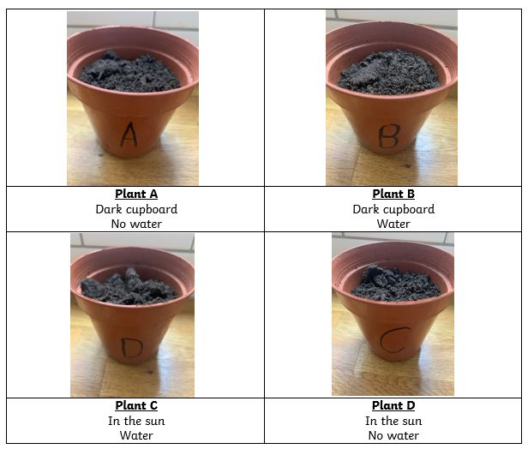

___________________________________________________________________________
___________________________________________________________________________
___________________________________________________________________________
___________________________________________________________________________
___________________________________________________________________________
___________________________________________________________________________
___________________________________________________________________________
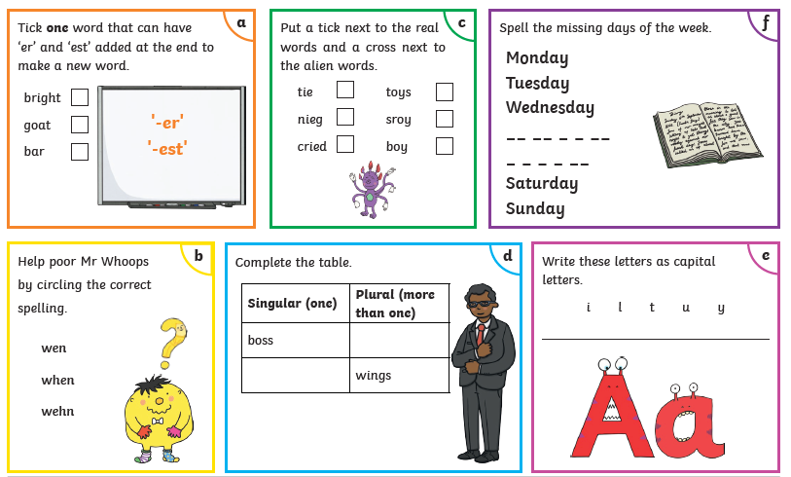
Thursday 2nd July
Spellings – Activity Mat
Thursday 2nd July
Maths – Ordinal Numbers

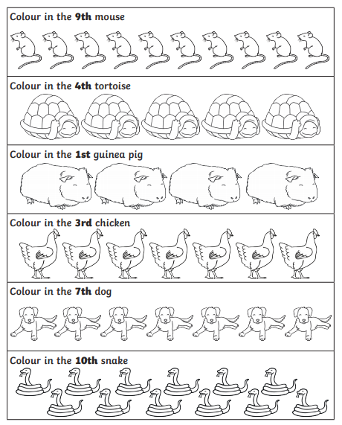
Look at the 4 plants from Mrs. Moore’s experiment. These pictures were taken a few weeks later. Was your prediction correct? Can you describe what has happened and why?

Friday 3rd July
Topic – Science Experiment - Results

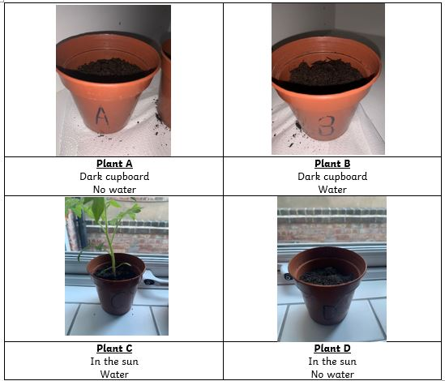

___________________________________________________________________________________________________________________________________________________________________________________________________________________________________________________________________
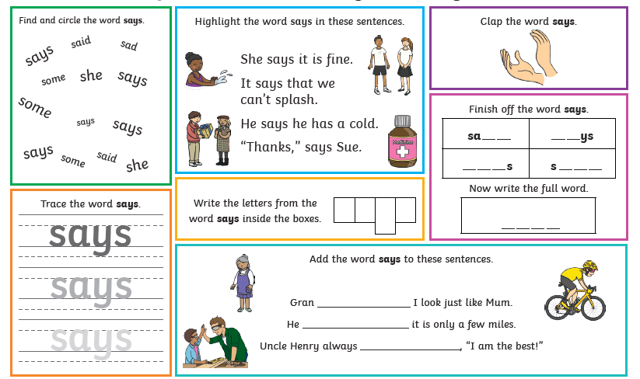
Friday 3rd July
Common Exception Word Mat - says
Friday 3rd July
Maths – Missing Number Problems

