

|  |  |
| --- | --- |
| +10 | -10 |
|  |  |

Ones

Tens

One more: One Less:

|  |  |  |
| --- | --- | --- |
| H | T | O |
|  |  |  |

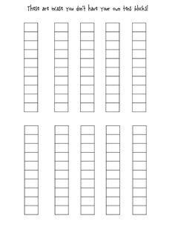

Our number in words:

_____________________________________________

100

0

Record on a number line:



Our Number is:

Odd or Even?