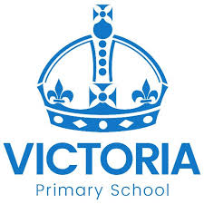
School Council Intent

At Victoria Primary School, we intend to use School Council to create pupils who understand their own learning and support the learning of their peers. Our School Council is led by pupil passions and will allow this to choose the projects that it supports so that children have a sense of responsibility and ownership.

It is imperative for children at Victoria Primary School to begin the next stage of their education knowing that they have the learning skills they need to achieve their aspirations. They have a curiosity of the world around them and a sense of their place in it.

This intended outcome is to create inspired young people who have a responsibility to being the best that they can be personally, but also a moral responsibility to building a better community as they go forward and make choices of their own as young people.

