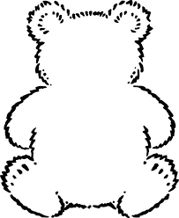

it

Can you practise writing these 4 words?

Bear 23

Bear 22

mug

us

up

is

in

if

hug

Black font: These are phonics sounds. Your child needs to learn the pure sound, not the letter of the alphabet.

Green font: These are high frequency words that your child will regularly see in books.

Blue font: These are ‘tricky words’ which aren’t decodable.

these words

Black font: These are phonics sounds. Your child needs to learn the pure sound, not the letter of the alphabet.

Green font: These are high frequency words that your child will regularly see in books.

Blue font: These are ‘tricky words’ which aren’t decodable.

these words