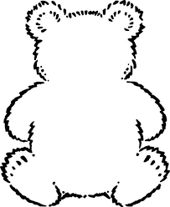

hip

hum

Bear 21

Bear 20

up

it

in

hop

is

hit

Black font: These are phonics sounds. Your child needs to learn the pure sound, not the letter of the alphabet.

Green font: These are high frequency words that your child will regularly see in books.

Blue font: These are ‘tricky words’ which aren’t decodable.

these words

Black font: These are phonics sounds. Your child needs to learn the pure sound, not the letter of the alphabet.

Green font: These are high frequency words that your child will regularly see in books.

Blue font: These are ‘tricky words’ which aren’t decodable.

these words