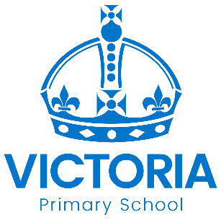

Cadbury Class
Newsletter: 7th January 2020

Welcome Back and Happy New Year to you all.

This Term
For the first couple of weeks, we will be revisiting classroom rules and focussing on our school motto of Work Hard: Be Kind. We will then study Gruffalo’s Child to develop reading skills, writing and spelling of key words. This will then be followed by our main topic – WWF (World Wide Fund for Nature) which will culminate with our next open day on Friday 27th March to coincide with Earth Hour. We will be learning about different habitats around the world and the impact climate change and deforestation is having on endangered animals. We will be then be creating an exhibition open to parents, carers and pupils and we look forward to seeing you on Friday 27th March at 2.30pm!

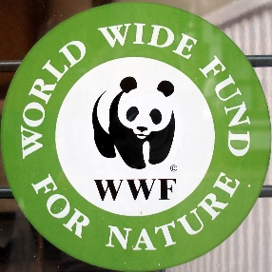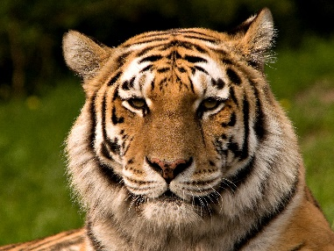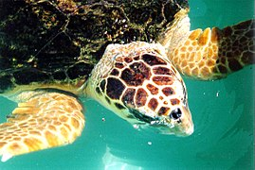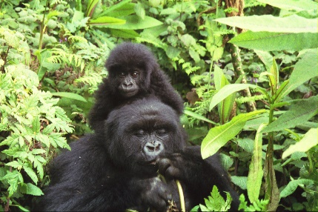

Drobox
We have created a Dropbox that is full of resources, leaflets and information on a range of topics such as EHCP requests, transition, sleeping, toileting, social stories and much more.

How to access Dropbox:
www.dropbox.com
Username: victoriaforum@outlook.com
Password: Victoria

Should you have any questions, or need any support please do not hesitate to contact us and remember to keep visiting our Cadbury Class webpage at www.victoriaprimaryschool.org.uk which we aim to update each week!

Cadbury Class Team.

Diary Dates: New Year 2020

Date | Year Group | Time | Event
Wednesday 22nd January | Years 3 - 6 | p.m. | Road Safety Quiz Competition
Tuesday 11th February | All | day | National Safer Internet Day
Thursday 13th February | Year 1 | p.m. | Zoo expo for Year 1 parents
Friday 14th February | All | 3.15 pm | School Closes for half term break
Monday 24th February | All | 8.45 | School re-opens
Thursday 5th March | All | day | World Book Day
Thursday 12th March | All | day | Sports Relief Charity Day
Thursday 19th and  Friday 20th March | All | p.m. | Mother’s Day Afternoon Tea
Friday 27th March | Cadbury Class | 2.30pm | Exhibition for WWF
Friday 27th March | All | 2.30pm | Earth Hour

