We are always in the mood for good food!
We are Aspens Services, a market leading contract catering company specialising in school food.

We only work in the education sector so we know what our customers want. Mixing this knowledge with an understanding of what’s hot in the food world sparks creativity and excitement in our chefs. Our kitchens provide delicious home cooked food each day and cater for individual dietary requirements.

We make sure that our Food Festival menus are packed with comfort dishes and, at the same time, we help pupils to take their first steps with new tastes to explore.

We don’t just provide food, we play our part to educate children and raise awareness about nutrition, food and where it comes from, so that they can make informed and mindful choices. Feeding our future.

Menu
The school menu rotates on a three-week basis and refreshes for Autumn/Winter and Spring/Summer seasons.

How school meals can support your child’s diet

All children need a nutritious, balanced meal to grow and meet their full potential.

School meals need to be compliant with the School Food Standards. These were created to help children develop healthy eating habits and ensure that they get the energy and nutrition they need across the whole school day. Therefore, parents should be able to trust that the school’s menu has been developed based on scientific nutrition research.

Click on the link to find out more about the the Governments School Meals Food Standards: https://www.gov.uk/school-meals-food-standards

Free school meals

Every Key Stage One pupil is entitled to a free school meal, under a Government programme called Universal Infant Free School Meals. There is no need for you to apply for this, it will save you time and money every day on making packed lunches, and in our experience pupils who take up their school meals become more adventurous and open to trying new foods.

Free School Meals are available to Key Stage Two pupils whose families receive:

- Universal Credit and your household income after tax is less than £7,400 per year (not including any benefits you get)
- Child Tax Credit, as long as you are not getting Working Tax Credit and have an annual income of less than £16,190
- Income-related Employment and Support Allowance
- Income Support
- Income-based Jobseeker's Allowance
- The guaranteed part of Pension Credit
- Asylum seeker support.
- It is also available to looked-after children, pupils who have been adopted and those whose parents are currently serving military personnel.

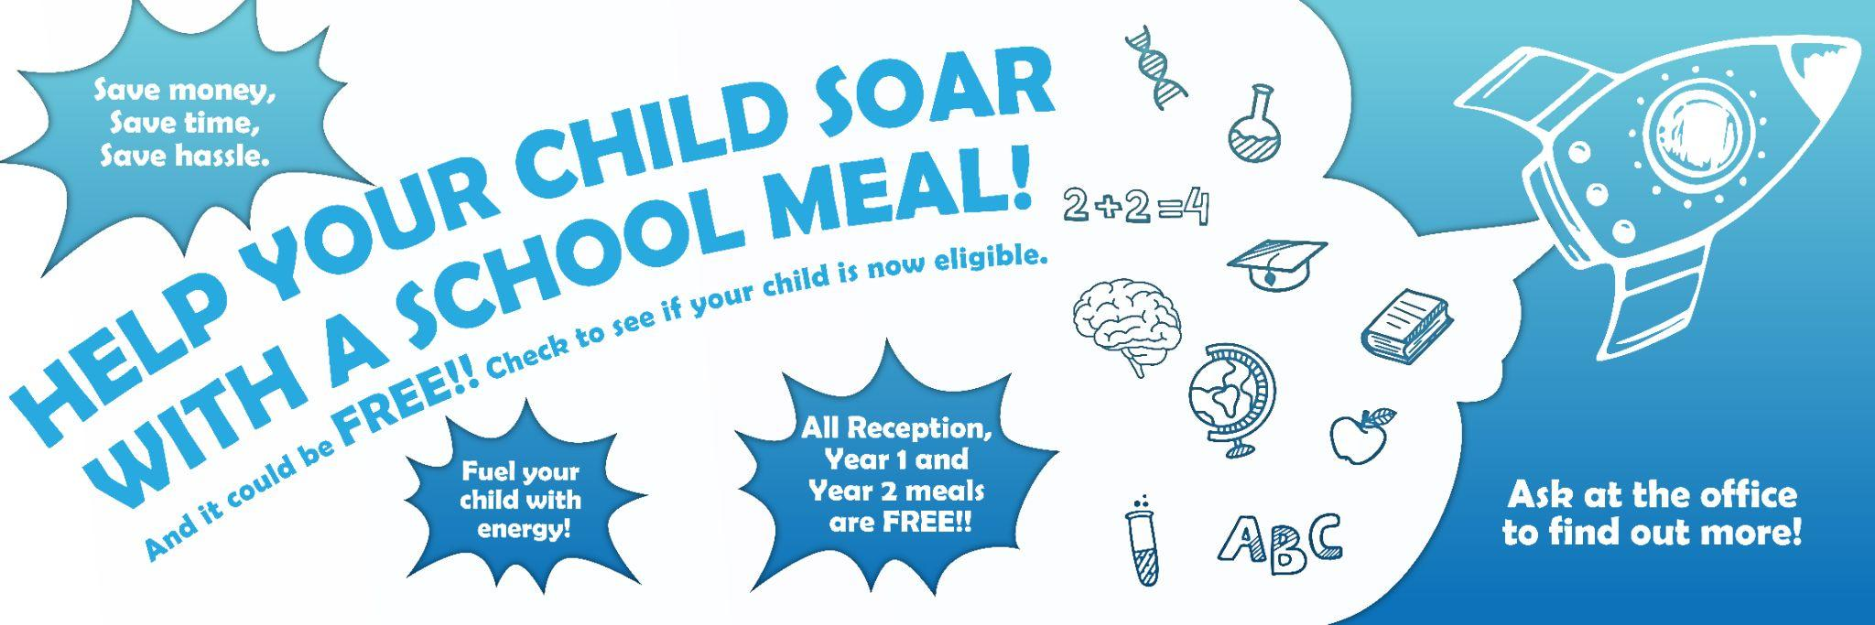

Please request the relevant form from the school office or scan/click to find out more or click here: https://www.gov.uk/apply-free-school-meals

Special Diets
Special diets are an integral part of our catering provision, whether as a result of an ethical or religious belief or a food intolerance or allergy. To register any special diets as a requirement please complete and return the special diets form to the school as soon as possible.

Our Planet

We work closely with our clients and suppliers to be as environmentally friendly as we can. By making lots of small changes, we can make a big difference. We care about the future and continue to focus on responsible sourcing, using seasonal produce, increasing our focus on plant-based recipes, making our menus more sustainable, keeping waste to a minimum and reusing and recycling to reduce the impact we have.

Join Our Team
It takes some pretty special people to make sure that we give our school children and young adults great food every day. We are keen to add to our teams with talented people and so if you are looking for an opportunity to challenge yourself and learn new skills, let us know.

