Our Uniform – buy anywhere

Please ensure all items are marked with your child's name; with around 350 children in school, there is roughly a 1 in 350 chance of reuniting a lost item of unnamed clothing with its owner!

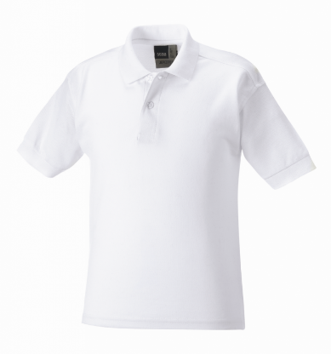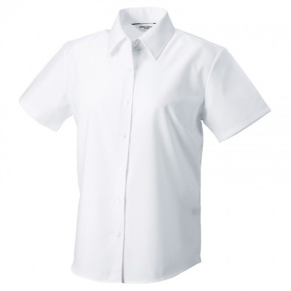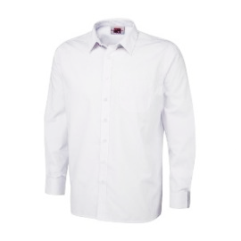
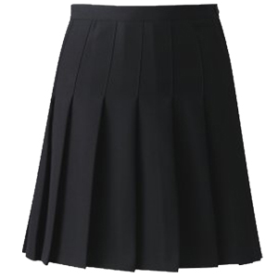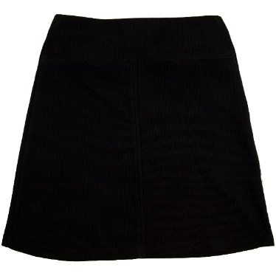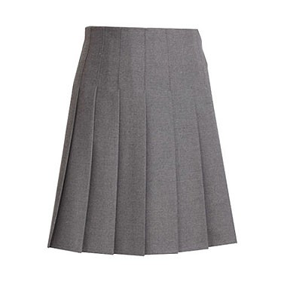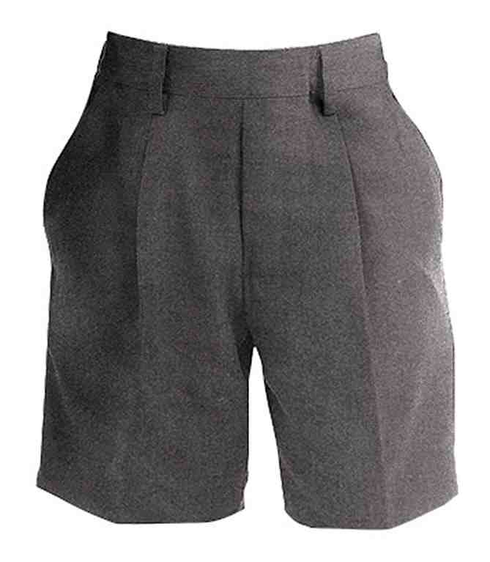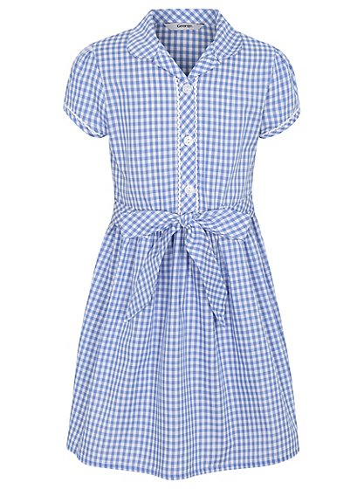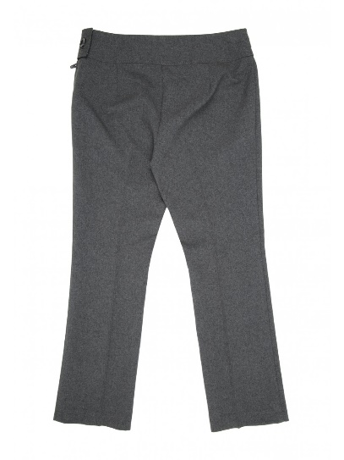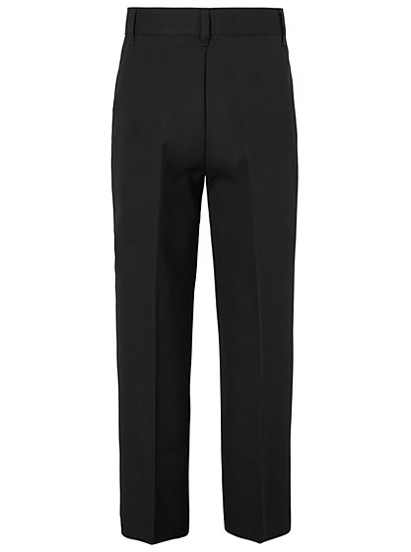

School jumpers, cardigans and book bags can be ordered and delivered directly from https://www.schoolwearsolutions.com A small amount of stock is held at the school office.
Our Uniform – buy anywhere

School footwear is PLAIN – BLACK – ANKLE HEIGHT
Footwear must be safe for children to run around in at break times but also
smart enough to make them feel proud of our whole school’s appearance.
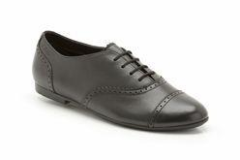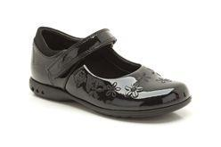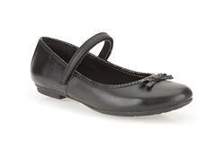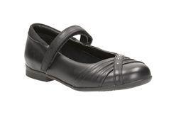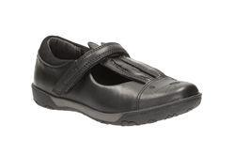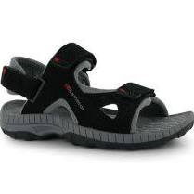
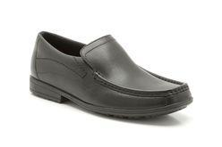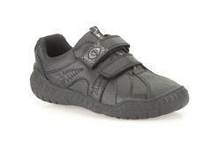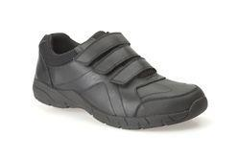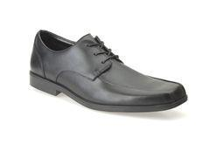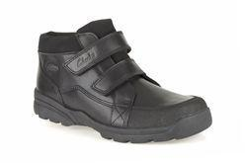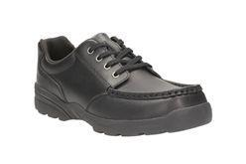

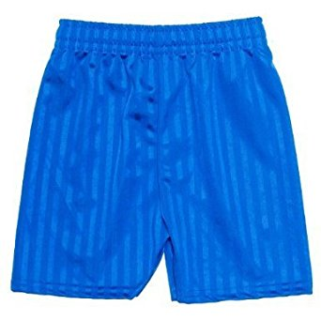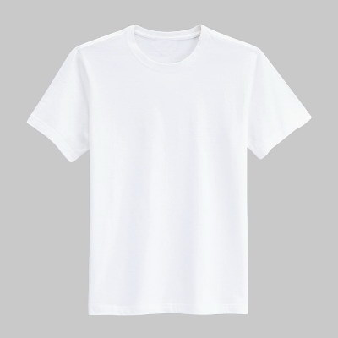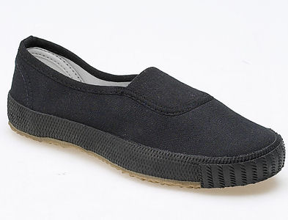
For PE:
NOT Our Uniform

School footwear is PLAIN – BLACK – ANKLE HEIGHT
Footwear must be safe for children to run around in at break times but also
smart enough to make them feel proud of our school’s appearance.

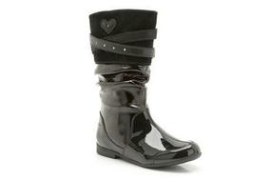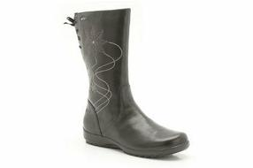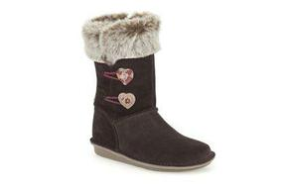
Not ankle height. Not plain Not ankle height. Not plain. Not plain

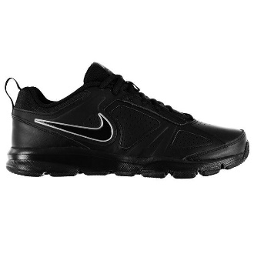. 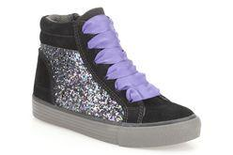 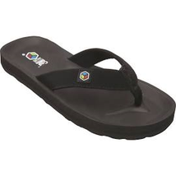
Not plain. Not plain. Unsafe - no ankle strap or toe joint protection.

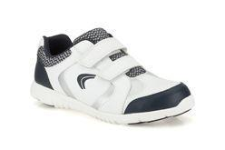. 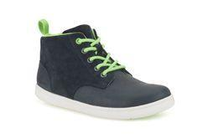 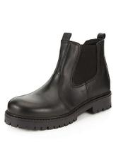
Casual. Not black Too chunky for our floors!

Expensive branded trainers are a waste of money and so are not allowed.
We are active at playtimes for at least 7 hours a week -
that is the same as 16 full school days of non-stop running around every term!
Shoes don’t last long when growing feet use them in this way.

NOT Our Uniform

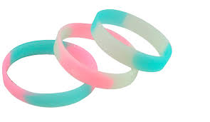
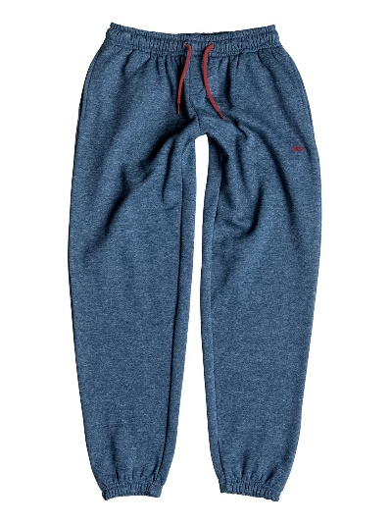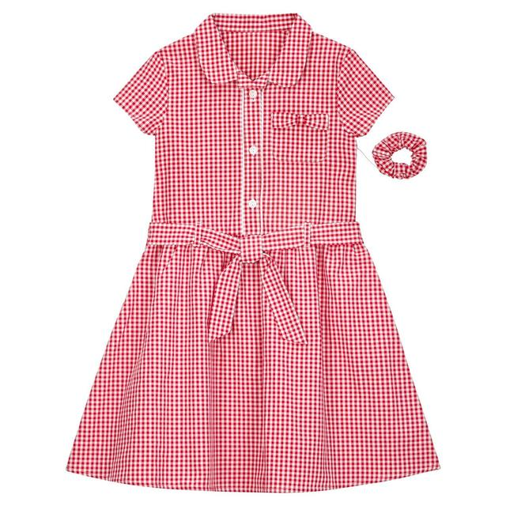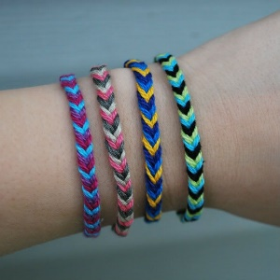
Casual – not our uniform Not our colour Wrist Accessories

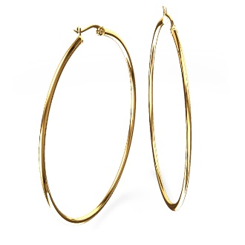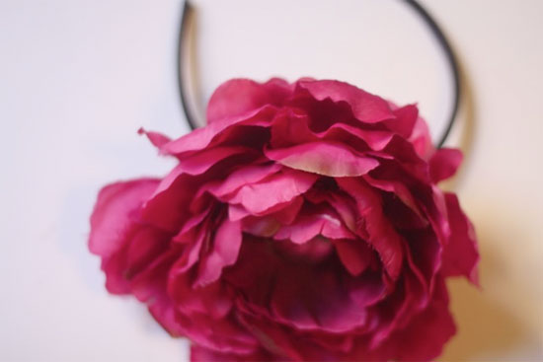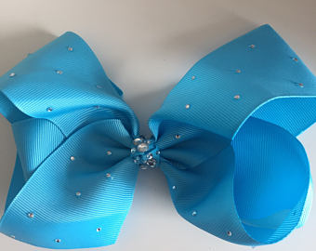
Dangerous at playtimes Hair Fashion Accessory Hair Fashion Accessory

Fashion items are not part of a child’s personality, individuality or character
so are not allowed in school.

We love our pupils’ ACTUAL individuality - their sense of humour, kindness, quirks, athletic nature, decisiveness, openness, honesty, sensitivity etc etc etc – these are VERY welcome in school.

