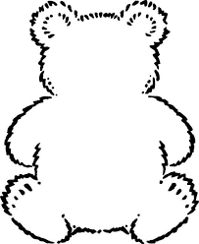

y

j

n

e

k

v

Bear 6

Bear 5

z

w

Black font: These are phonics sounds. Your child needs to learn the pure sound, not the letter of the alphabet.

Green font: These are high frequency words that your child will regularly see in books.

Blue font: These are ‘tricky words’ which aren’t decodable.

these words

Black font: These are phonics sounds. Your child needs to learn the pure sound, not the letter of the alphabet.

Green font: These are high frequency words that your child will regularly see in books.

Blue font: These are ‘tricky words’ which aren’t decodable.

these words