Monday 8th June
Good morning, I hope you had a lovely weekend. This week’s theme is summer (I hope I don’t scare the sun away with this theme!)
To get your brains thinking of all things summer, I have set some challenges for you. You need to look as carefully as you can at the pictures to see if you can see what is hiding. It could be anything at all – but all of the hidden objects are things that you might see in summer.
You can write in the missing word or leave a voice message to tell me what you can see. If you write, use your sound mat to help – some words are difficult so you might need some help!
If you want to give me a challenge, think of your own summer object and describe it for me to guess. Like this: My summer object is hot, hot, hot. It always comes out on sunny days. I can see smoky flames rising into the sky as it cooks our dinner. Can you guess what it is?
A barbecue! Great job!
Resources: What can you see pages, Sound mat
Answer sheet to go live at 3pm.

Tuesday 9th June
Hello everyone,
Today’s job is a writing challenge. I have lots of summery objects that you need to label.
Remember to:
- Say the word
- Pull out the different sounds e.g. s-u-n
- Blend them together
- Find each grapheme on your sound mat
- Write the graphemes
When you have the words written, see if you can write these sentences:
It is a hot day.
The sand is wet.
The hat got lost.
Don’t forget you capital letters and full stops. There is an alphabet strip with capital letters on if you need it.
Resources: Picture bank with omitted words
Alphabet with Capital Letters included.

Wednesday 10th June
Good morning,
A few months ago, when spring first came and the flowers started to grow, we took some time to create some drawings and paintings of daffodils. They were beautiful pictures! Today we would like you to have another go and to create pictures of the living things you can see outside. You might want to choose a plant or a bunch of flowers. You might choose a tree or even a bug like a ladybird. All you need to be able to do is set up your paper and pencil in a place where you can look really carefully at what you want to draw. This means that you can look at all of the different shapes and colours that you will need. You could paint, colour or collage your picture once it is complete.
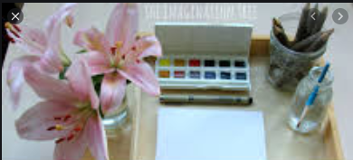
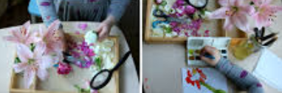

We can’t wait to see your art,
Mrs Evans and Miss Murphy

Thursday 11th June
Hello Boot and Bell Class,
Today we are going to measure how tall you are! I bet you have grown so much over lockdown. All you will need are:
- Yourself
- Paper
- Pen
- Scissors
Draw round your hands lots of times.
Cut out the hands.
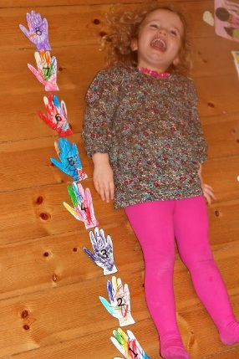
Lay on the floor – have you made enough hands to make your height? Do you need some more? Estimate how many more hands you might need – 1? 5? Label each hand with a number to show how many hands you needed. You could measure a brother or sister, do you think they will need more or less hands than you? How many hands do you think they will need?

Friday 12th June
Good morning,
Today we would like the children to practise their estimating skills. Estimating is havinng a god guess at how many objects there are. Goood estimates are really near to the actual aount. The more you practise the better at estimting you will get!
If your child is finding it difficult to estimate, guide them by first asking if they think there is more or less than 5? 10?
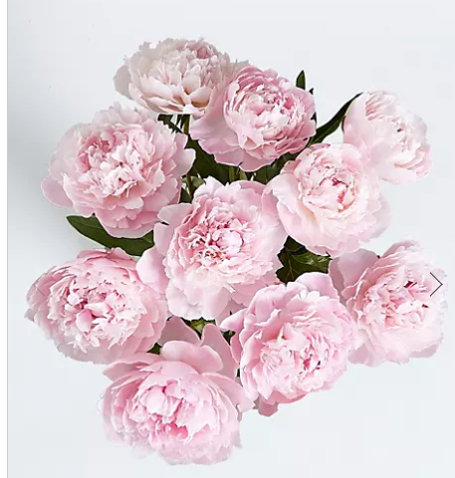
- Estimate how many you think there are.
- Count up how many flowers there are.
- Were you close?
- Was your estimate too high or too low?

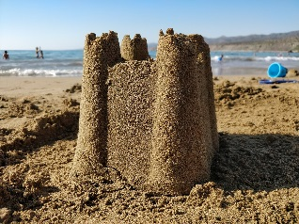
- Estimate how many you think there are.
- Count up how many sandcastles there are.
- Were you close?
- Was your estimate too high or too low?

- Estimate how many you think there are.
- Count up how many ice creams there are.
- Were you close?
- Was your estimate too high or too low?

- Estimate how many you think there are.
- Count up how many ice bees there are.
- Were you close?
- Was your estimate too high or too low?
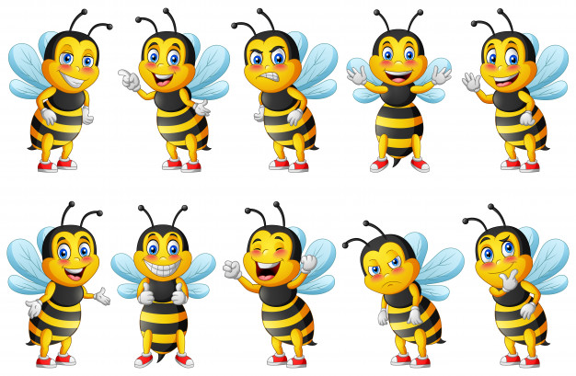

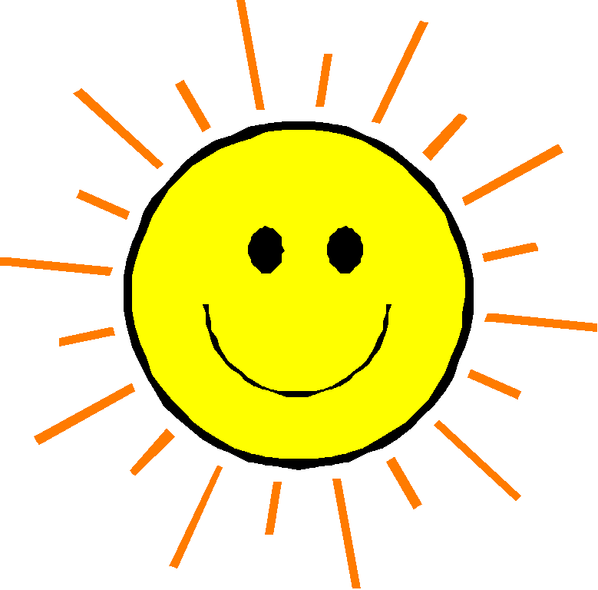
- Estimate how many you think there are.
- Count up how many suns there are.
- Were you close?
- Was your estimate too high or too low?

