Wednesday 3rd June
Welcome back,
We hope you had a wonderful half term enjoying the sun shine! This half term we will be working on a different theme each week. This week’s theme is ‘Vehicles and Transport’
https://www.bbc.co.uk/iplayer/episodes/p06m8m6y/caties-amazing-machines
Choose an episode of Catie’s Amazing Machines on
BBC iPlayer. See if you can answer some of the questions that we have set you.

When you have finished, make your own video to tell us some fats that you have learnt.
- What ‘job’ does your vehicle have to be able to do?
- What is special about your vehicle? Is it strong? Fast?
- Who uses it?

Thursday 4th June

1. Write out the words onto paper
2. Chop up each individual word.
3. Say a sentence for your child to read, choose the words and then put into order.
4. You can ask your child for more words that they might want to add- for example they might say ‘The bright pink digger was noisy’.
5. Add their new words to the set and allow them to build their own sentence.
A | The
big | red | tall | small
bike | car | bus | truck
is
fast | strong | loud | slow
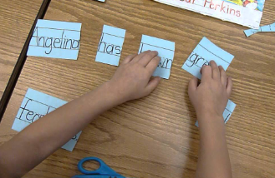

Friday 5th June
Good morning,
Today we would like the children to practise their estimating skills. Estimating is havinng a god guess at how many objects there are. Goood estimates are really near to the actual aount. The more you practise the better at estimting you will get!
If your child is finding it difficult to estimate, guide them by first asking if they think there is more or less than 5? 10?
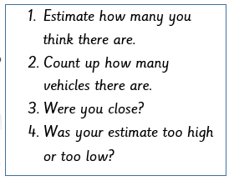
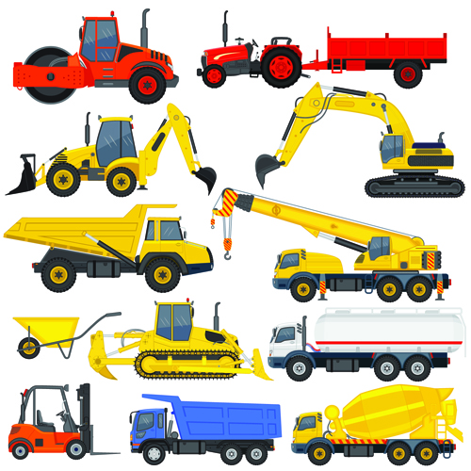
- Estimate how many you think there are.
- Count up how many vehicles there are.
- Were you close?
- Was your estimate too high or too low?
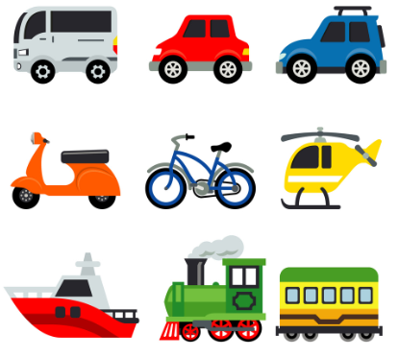

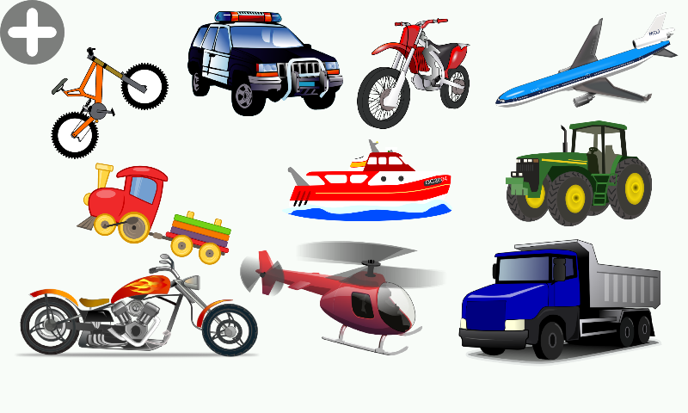

Here are some really simple estimating games your child could play to practise their estimating skills.
